VLSI INTERNSHIP – TASK 1 COMPLETION @ INTERNSPARK

Candidate Information :
- Name: Garshakurthi Ajay
- Candidate ID: IS-2026-8378
- Domain: Very Large Scale Integration (VLSI) Intern

Goal :
Write RTL for a small digital block (e.g., 8-bit ALU or simple RISC datapath) and verify functionality with testbenches.
Requirements:
- Create synthesizable Verilog/SystemVerilog modules
- Write comprehensive testbench with directed and random tests
- Simulate using ModelSim/GTKWave or any simulator

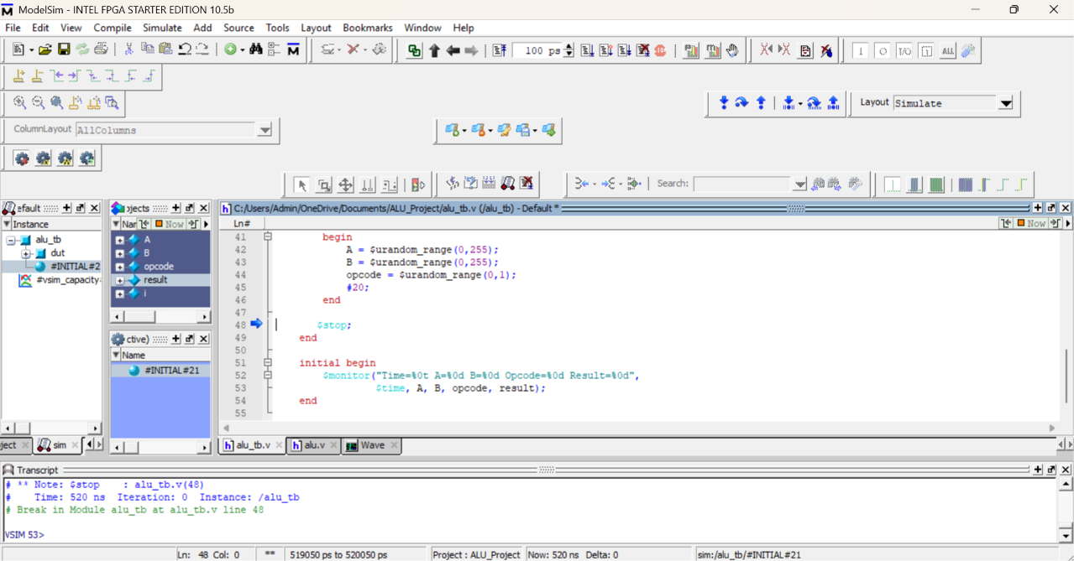

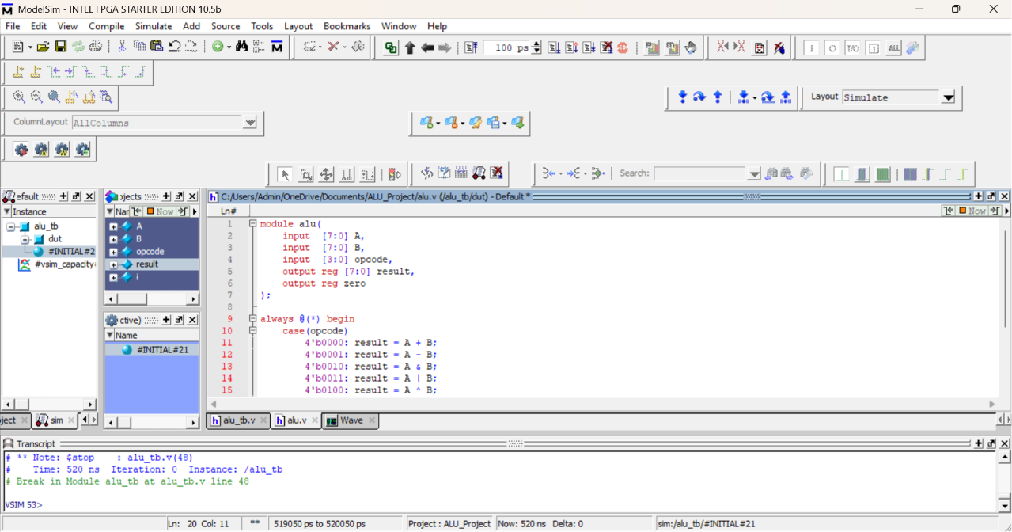

Deliverables:
1. RTL Source Files and Testbench
- Developed a synthesizable 8-bit ALU in Verilog HDL supporting Addition, Subtraction, AND, OR, XOR, NOT, Increment, and Decrement operations.
- Created a comprehensive testbench with both directed and random test cases for functional verification.
2. Simulation Wave Screenshots and Coverage Summary
- Simulated the design using ModelSim and captured waveform outputs for verification.
- Achieved 100% opcode coverage by testing all eight ALU operations.
- Waveform results confirmed correct functionality for all directed and random test scenarios.
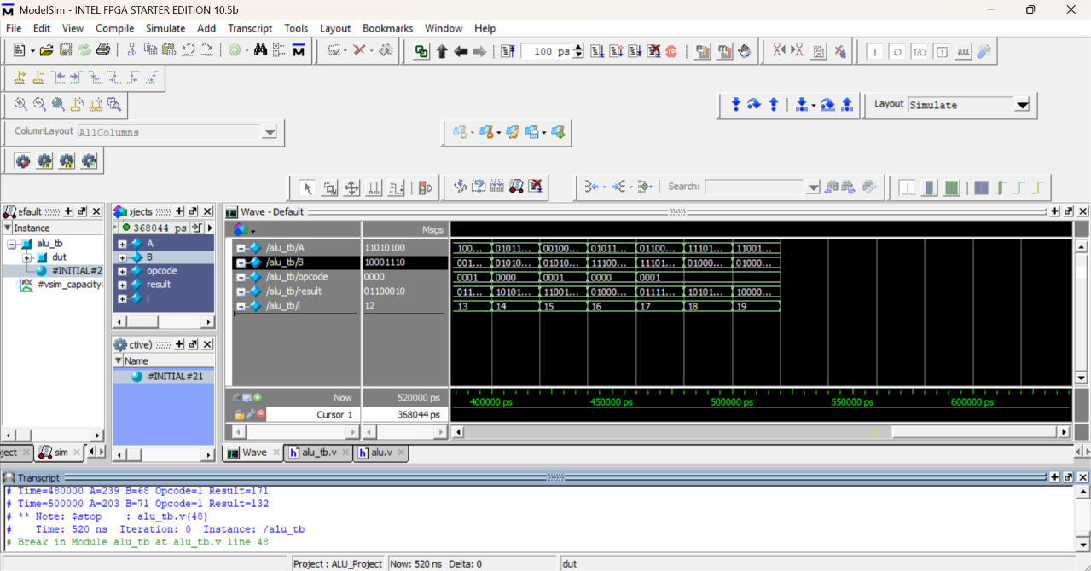

✅ Final Summary
- Designed and implemented an 8-bit ALU in Verilog HDL supporting eight operations: Addition, Subtraction, AND, OR, XOR, NOT, Increment, and Decrement.
- Developed a comprehensive testbench with both directed and random test cases. Verified functionality through ModelSim simulation, and waveform analysis confirmed correct operation for all implemented opcodes.
- Successfully completed RTL design, verification, and functional coverage requirements.
Linkedin Task 1 completion post link :
https://www.linkedin.com/posts/ajay-garshakurthi-248572362_vlsi-rtldesign-verification-ugcPost-7475043389634187265-VSu0/?utm_source=share&utm_medium=member_desktop&rcm=ACoAAFoj4dgB5Sv8ySZv8M7rNmoPQc59xNJI5Gw

